# **Name: Abdurrahman Qureshi**

# **Roll No: 242466**

Practical No: 5

1) **Get total number of rows of emp table**

QUERY:

[SELECT](http://localhost/phpmyadmin/url.php?url=https://dev.mysql.com/doc/refman/8.0/en/select.html) [COUNT](http://localhost/phpmyadmin/url.php?url=https://dev.mysql.com/doc/refman/8.0/en/aggregate-functions.html%23function_count)(*) FROM `emp`;

OUTPUT:

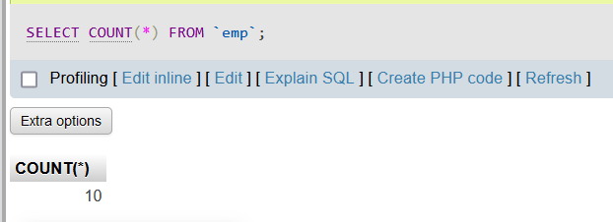

2) **Get number of clerks**

QUERY:

SELECT COUNT(*) FROM emp WHERE job = "CLERK";

OUTPUT:

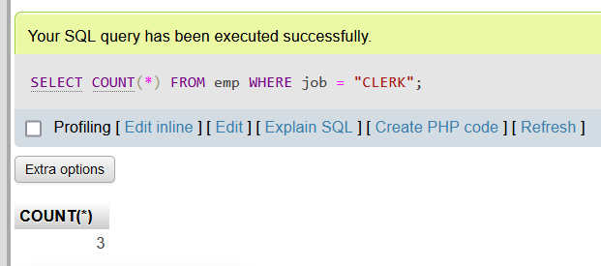

3) **Get total salary to employees**

QUERY:

SELECT SUM(salary) AS total_salary FROM emp;

OUTPUT:

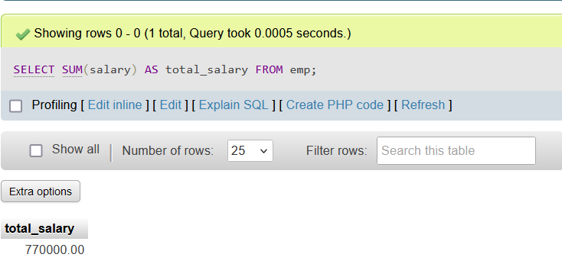

4) Get **Total commission to all salesman**

QUERY:

[SELECT](http://localhost/phpmyadmin/url.php?url=https://dev.mysql.com/doc/refman/8.0/en/select.html) [SUM](http://localhost/phpmyadmin/url.php?url=https://dev.mysql.com/doc/refman/8.0/en/aggregate-functions.html%23function_sum)(salary) AS total_salary FROM emp WHERE job = "SALESMAN";

OUTPUT:

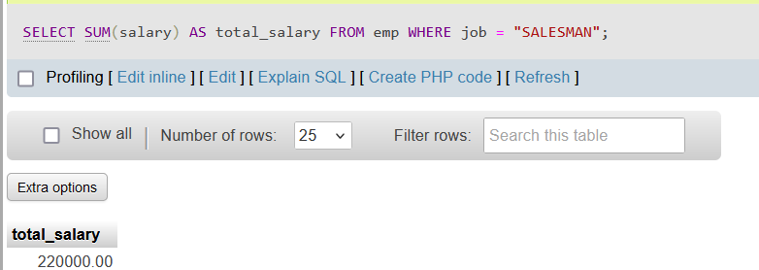

5) **Get average salary of the table emp**

QUERY:

SELECT AVG(salary) AS average_salary FROM employees;

OUTPUT:

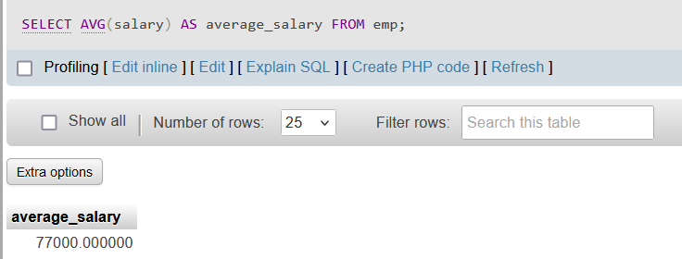

6) **Get min salary of the table emp**

QUERY:

SELECT MIN(salary) AS minimum_salary from emp;

OUTPUT:

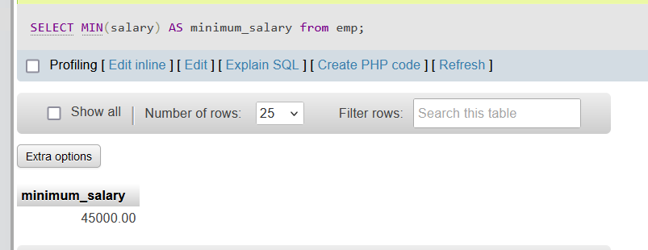

7) **Get max salary of the table emp**

QUERY:

SELECT MAX(salary) AS minimum_salary from emp;

OUTPUT:

